# **Cassava Leaf Wilt Detection Using Deep Learning Approach**

### **PROJECT PHASE 2 REPORT**

#### ***Submitted by***

**CH. Lakshman Kumar [U19IT012]**

**K. Sumanth [U19IT026]**

**K. Venkat Prem Sai [U19IT031]**

**T. Chinni Krishna [U19IT050]**

#### 

#### **Under the guidance of**

#### **DR.K. Ramesh Kumar**

#### **prof And head- it department**

#### ***in partial fulfillment for the award of the degree of***

## **BACHELOR OF TECHNOLOGY IN INFORMATION TECHNOLOGY**



## **DEPARTMENT OF INFORMATION TECHNOLOGY**

## **BHARATH INSTITUTE OF SCIENCE AND TECHNOLOGY**

**BHARATH INSTITUTE OF HIGHER EDUCATION AND RESEARCH,**

**CHENNAI - 600073**

### **JANUARY 2023**

# 

# BHARATH INSTITUTE OF SCIENCE AND TECHNOLOGY

# CHENNAI

# DEPARTMENT OF INFORMATION TECHNOLOGY

**U18PRIT8P2 - PHASE Ⅱ REPORT**

## BONAFIDE CERTIFICATE

##### Certified that this Report titled **“Cassava Leaf Wilt Detection Using Deep Learning Approach”** is the bonafide work of **CH. Lakshman Kumar ( U19IT012),K. Sumanth (U19IT026), K. Venkat Prem Sai(U19IT031),T. Chinni Krishna(U19IT050)** who carried out the work under my supervision. Certified further that to the best of my knowledge the work reported herein does not form part of any other thesis or dissertation on the basis of which a degree or award was conferred on an earlier occasion on this or any other candidate.

**Head of the department supervisor**

**Dr. K. Ramesh Kumar Dr. K. Ramesh Kumar**

**Professor and Head professor and head**

**Department of Information Technology Department of Information Technology Bharath Institute of Higher Education and Research Bharath Institute of Higher Education and Research**

**Chennai – 600 073 Chennai-600 073**

Project Phase- ⅠⅠ Viva Voce examination on …………………….

**INTERNAL EXAMINER** **EXTERNAL EXAMINER**

**DECLARATION**

# We declare that this project report titled **Cassava Leaf Wilt Detection Using Deep Learning Approach**

submitted in partial fulfillment of the degree of **B. Tech in (Information Technology)** is a record of original work carried out by us under the supervision of **Dr.k.Ramesh kumar**, and has not formed the basis for the award of any other degree or diploma, in this or any other Institution or University. In keeping with the ethical practice in reporting scientific information, due acknowledgements have been made wherever the findings of others have been cited.

**CH. Lakshman Kumar**

**(U19IT012)**

**K. Sumanth**

**(U19IT0026)**

**K.Venkat Prem Sai**

**(U19IT031)**

**T.Chinni Krishna**

**(U19IT050)**

**Chennai**

***/ /2023***

**ACKNOWLEDGMENT**

First of all, I express my sincere thankfulness to the almighty, for bestowing his blessings throughout this project work. I express my gratitude to my parents for their care, support, prayers and love.

My sincere thanks to our Honourable Chairman **Dr.S.Jagathrakshakan,** Honourable President, **Dr.J.Sundeep Aanand** and Managing Director **Dr.E.Swetha Sundeep Aanand,** Bharath Institute of Higher Education and Research, for their kind words and enthusiastic motivation which has inspired me a lot in completing my Project.

I would like to express my deep gratitude to our **Dr. Vijaya Bhaskar Raju** vice chancellor,**Dr. M. Sundararajan** pro vice-chancellor (Academics),  **Dr. Hari Prakash** Additional Registrar ,**Dr. R.M. Suresh** pro vice -chancellor with Additional In charge Controller of Examinations ,**Dr. J. Hameed Hussain** Dean Engineering who are responsible for moulding my thoughts in completing my Project.

I am thankful to the **Dr.V .Khanna Dean-IT** and **Head of the Department** **Dr. K. Ramesh Kumar** and all staff members of the Department of INFORMATION TECHNOLOGY, BIHER, for their encouragement and guidance throughout the course of this project work.

.

I wish to express my sincere profound gratitude to my esteemed and endowed Project guide **Dr. K. Ramesh Kumar** Prof and Head-IT for her inspiring guidance, healthy criticism, valuable suggestions and constant encouragement throughout the period of project.

I sincerely wish to express my thanks to the staff members of Library, BIHER for their valuable during this project work. I would like to thank the authors of various journals and books whose works and results are used in the project.

.

**CH. Lakshman Kumar (U19IT012)**

**K. Sumanth(U19IT0026)**

**K.Venkat Prem Sai (U19IT031)**

**T.Chinni Krishna(U19IT050)**

###### TABLE OF CONTENTS

|  |  |  |  |  |  |  |  |  |  |  |  |  |  |  |  |  |  |  |  |  |  |  |  |  |  |  |  |  |  |  |  |  |  |  |  |  |  |  |  |  |  |  |  |  |  |  |  |  |  |  |  |  |  |  |  |  |  |  |  |  |  |  |  |  |  |  |  |  |  |  |  |  |
| --- | --- | --- | --- | --- | --- | --- | --- | --- | --- | --- | --- | --- | --- | --- | --- | --- | --- | --- | --- | --- | --- | --- | --- | --- | --- | --- | --- | --- | --- | --- | --- | --- | --- | --- | --- | --- | --- | --- | --- | --- | --- | --- | --- | --- | --- | --- | --- | --- | --- | --- | --- | --- | --- | --- | --- | --- | --- | --- | --- | --- | --- | --- | --- | --- | --- | --- | --- | --- | --- | --- | --- | --- |
| |  |  |  | | --- | --- | --- | | CHAPTER NO. | TITLE | PAGE | |  | ABSTRACT | 6 | |  | LIST OF FIGURES | 7 | |  | LIST OF ABBREVATIONS | 7 | |  | **CHAPTER 1** |  | | 1.1 | INTRODUCTION OF PROJECT | 8 | | 1.1.1 | INTRODUCTION OF DOMAIN | 9 | | 1.2 | OBJECTIVE OF THE PROBLEM | 13 | | 1.3 | SCOPE OF THE PROJECT | 14 | |  | **CHAPTER 2** |  | | 2.0 | LITERATURE REVIEW | 15 | |  | **CHAPTER 3** |  | | 3.1 | EXISTING SYSTEM | 21 | | 3.2 | PROPOSED SYSTEM | 22 | | 3.2.1 | OBJECTIVE OF THE PROJECT | 23 | | 3.2.2 | PROPOSED SYSTEM ADVANTAGES | 23 | |  | **CHAPTER 4** |  | | 4.1 | MODULE DESCRIPTION | 25 | | 4.2 | ALGORITHM AND PROPOSED WORK | 28 | | 4.4 | COMPARITIVE STUDYOF EXISTING AND PROPOSED SYSTEM | 29 | |  | **CHAPTER 5** |  | | 5.1 | CONCLUSION | 30 | | 5.2 | FUTURE SCOPE | 30 | | 6 | REFERENCE | 31 | |

**ABSTRACT**

The identification of disease on the plant is a very important key to prevent a heavy loss of yield and the quantity of agricultural product. The symptoms can be observed on the parts of the plants such as leaf, stems, lesions and fruits. The leaf shows the symptoms by changing color, showing the spots on it. This identification of the disease is done by manual observation and pathogen detection which can consume more time and may prove costly. The aim of the project is to identify and classify the disease accurately from the leaf images. The steps required in the process are Preprocessing, Training and Identification. For identification of disease features of leaf such as major axis, minor axis etc. are extracted from leaf and given to classifier for classification.

In our project we have used cassava leaf for identifying its disease. We have used two proposed algorithms namely Support Vector Machine (SVM) as existing and Convolution Neural Network (CNN). This proposed Convolution Neural Network (CNN)algorithm will be compared to an existing algorithms in terms of accuracy.

**PAGE NO**

**APPENDIX - 1 33-37**

**APPENDIX – 2 38-43**

**LIST OF FIGURES**

**FIGURE TITLE PAGE NO**

1. System Architecture 22
2. UML Diagram 22
3. Use case Diagram 23
4. Flow Chart 27

**LIST OF ABBREVIATIONS**

**SVM** SUPPORT VECTOR MACHINE

**CNN** CONVENTIONAL NEURAL NETWORK

**CBSD** CASSAVA BROWN STREAK 10 DISEASE

**CMD** CASSAVA MOSAIC VIRUS DISEASE

**CHAPTER 1**

**1. INTRODUCTION**

* 1. **Introduction of Project**

Now days, a new concept of smart farming has been introduced where the field conditions are controlled and monitored using the self operating systems. The self recognition of the disease is based on the identification of the symptoms of disease. So that information about the disease occurrence could be quickly and accurately provided to the farmers, experts and researchers. This in turn reduces the monitoring of large field by human being. In disease recognition from image the key is to extract the characteristic feature of the diseased region. According to the disease the features may vary.

The features that are extracted from the image are color, shape, texture etc. Sometimes for detection of the disease more features are extracted and these extracted features would increase the hardware as well as software cost. This further causes increase in the complexity and the computation time. Hence it is necessary to reduce the feature data. The occurrence of the disease on the plant may result in significant loss in both quality as well as the quantity of agricultural product.

This can produce the negative impact on the countries whose economies are primarily dependent on the agriculture. Hence the detection of the disease in the earlier stages is very important to avoid the loss in terms of quality, quantity and finance. Usually the methods that are adopted for monitoring and management of plant leaf disease are manual. One such major approach is naked eye observation. But the requirement of this method is continuous monitoring of the field by a person having superior knowledge about the plants and its corresponding diseases. Moreover, appointing such a person would prove costly. Another approach is seeking advice from the expert which may add the cost. Also, the expert must be available in time otherwise it may results in loss. Diagnosis of disease on plant can also be done in laboratory testing.

But this method requires satisfactory laboratory conditions along with professional knowledge. The pathogen detection methods can provide more accurate results. As the tests are carried out of field the cost may be high and could be time consuming. This paper suggests a system which can provide more accurate results related to the identification and classification of disease. It tries to replace the need of the experts to certain extent. Here, the captured image is first preprocessed to resize it and then converted to HSI color space format by using segmentation. The features such as major axis, minor axis, eccentricity are extracted from the image. In the last step, these features are given to the classifier to classify the disease occurred on the leaf.

**1.1.1 Introduction of Domain**

**Machine Learning:**

In the statistical context, Machine Learning is defined as an application of artificial intelligence where available information is used through algorithms to process or assist the processing of statistical data. While Machine Learning involves concepts of automation, it requires human guidance. Machine Learning involves a high level of generalization in order to get a system that performs well on yet unseen data instances.

Machine learning is a relatively new discipline within Computer Science that provides a collection of data analysis techniques. Some of these techniques are based on well established statistical methods (e.g. logistic regression and principal component analysis) while many others are not.

Most statistical techniques follow the paradigm of determining a particular probabilistic model that best describes observed data among a class of related models. Similarly, most machine learning techniques are designed to find models that best fit data (i.e. they solve certain optimization problems), except that these machine learning models are no longer restricted to probabilistic ones.

Therefore, an advantage of machine learning techniques over statistical ones is that the latter require underlying probabilistic models while the former do not. Even though some machine learning techniques use probabilistic models, the classical statistical techniques are most often too stringent for the oncoming Big Data era, because data sources are increasingly complex and multi-faceted. Prescribing probabilistic models relating variables from disparate data sources that are plausible and amenable to statistical analysis might be extremely difficult if not impossible.

Machine learning might be able to provide a broader class of more flexible alternative analysis methods better suited to modern sources of data. It is imperative for statistical agencies to explore the possible use of machine learning techniques to determine whether their future needs might be better met with such techniques than with traditional ones.

**CLASSES OF MACHINE LEARNING**

There are two main classes of machine learning techniques:

1. Supervised machine learning and unsupervised machine learning.

A. Examples of supervised learning Logistic regression (statistics) vs Support vector machines (machine learning) Logistic regression, when used for prediction purposes, is an example of supervised machine learning. In logistic regression, the values of a binary response variable (with values 0 or 1, say) as well as a number of predictor variables (covariates) are observed for a number of observation units. These are called training data in machine learning terminology. The main hypotheses are that the response variable follows a Bernoulli distribution (a class of probabilistic models), and the link between the response and predictor variables is the relation that the logarithm of the posterior odds of the response is a linear function of the predictors. The response variables of the units are assumed to be independent of each other, and the method of maximum likelihood is applied to their joint probability distribution to find the optimal values for the coefficients (these parameterize the aforementioned joint distribution) in this linear function. The particular model with these optimal coefficient values is called the “fitted model,” and can be used to “predict” the value of the response variable for a new unit (or, “classify” the new unit as 0 or 1) for which only the predictor values are known. Support Vector Machines (ML) are an example of a non-statistical supervised machine learning technique; it has the same goal as the logistic regression classifier just described: Given training data, find the best-fitting ML model, and then use the fitted ML model to classify new units. The difference is that the underlying models for ML are the collection of hyper planes in the space of the predictor variables. The optimization problem that needs to be solved is finding the hyper plane that best separates, in the predictor space, the units with response value 0 from those with response value 1. The logistic regression optimization problem comes from probability theory whereas that of ML comes from geometry.

Other supervised machine learning techniques mentioned later in this briefing include decision trees, neural networks, and Bayesian networks. B. Examples of unsupervised learning Principal component analysis (statistics) vs Cluster analysis (machine learning). The main example of an unsupervised machine learning technique that comes from classical statistics is principal component analysis, which seeks to “summarize” a set of data points in high-dimensional space by finding orthogonal one-dimensional subspaces along which most of the variation in the data points is captured. The term “unsupervised” simply refers to the fact that there is no longer a response variable in the current setting. Cluster analysis and association analysis are examples of non-statistical unsupervised machine learning techniques. The former seeks to determine inherent grouping structure in given data, whereas the latter seeks to determine co-occurrence patterns of items

**1.1.2 Image Enhancement:**

Image enhancement is one of the important stages for processing the image in digital image processing field. Image enhancement is the process of making images more useful and it also improves the quality of image. The reason why image enhancement is performed because it highlights interesting details in the image removes noise from the image and makes the image visually appealing. There are two broad categories of image enhancement techniques spatial domain technique and frequency domain technique. Spatial domain techniques works directly on the manipulation of image pixels whereas frequency domain is based on modifying the Fourier or wavelet transform of image. If manipulation is done directly on image pixels and if the image is noisy this means any unwanted information is added to the image then de-noising is performed in two parts detection of noise and removal of that particular noise. Noise generally comes from sensors, environmental conditions (rain, snow, lightening etc.) and transmission through noisy channel. De-noising is performed because the image could be visually unpleasant, bad compression or bad analysis. There are different noise types independent of spatial location and spatially dependent. The noises which are independent of spatial location are impulsive noise and AWGN (Additive white Gaussian noise)and the spatially dependent noise considers periodic noise.

**1.1.3 Digital Image Processing**

Two principal research paths evolve under the name of Digital Image Processing. The first one includes methods that attempt at answering question, was the image captured by the device it is claimed to be acquired with? By performing some kind of ballistic analysis to identify the device that captured the image or at least to determine which devices did not capture it.

The history of a digital image can be represented as a composition of several steps, collected into three main phases: acquisition, coding, and editing. These methods will be collected in the following under the common name of image source device identification techniques. The second group of methods aims instead at exposing traces of semantic manipulation (i.e. forgeries) by studying inconsistencies in natural image statistics.

Digital image processing allows one to enhance image features of interest while attenuating detail irrelevant to a given application, and then extract useful information about the scene from the enhanced image. This introduction is a practical guide to the challenges, and the hardware and algorithms used to meet them. Images are produced by a variety of physical devices, including still and video cameras, x-ray devices, electron microscopes, radar, and ultrasound, and used for a variety of purposes, including entertainment, medical, business (e.g. documents), industrial, military, civil (e.g. traffic), security, and scientific. The goal in each case is for an observer, human or machine, to extract useful information about the scene being imaged. An example of an industrial application is Often the raw image is not directly suitable for this purpose, and must be processed in some way. Such processing is called image enhancement.

**1.1.4 Image Analysis**

Image enhancement processing by an observer to extract information is called *image analysis*. Enhancement and analysis are distinguished by their output, images Vs scene information, and by the challenges faced and methods employed. Image enhancement has been done by chemical, optical, and electronic means, while analysis has been done mostly by humans and electronically. Digital image processing is a subset of the electronic domain wherein the image is converted to an array of small integers called *pixels*, representing a physical quantity such as scene radiance stored in a digital memory, and processed by computer or other digital hardware. Digital image processing, either as enhancement for human observers or performing autonomous analysis, offers advantages in cost, speed, and flexibility, and with the rapidly falling price and rising performance of personal computers it has become the dominant method in use.

* 1. **Objective of the Problem**

India is an agriculture country. 70% of Indian economy depends on agriculture but leaf infection phenomena causes the loss of major crops results in economic loss. Leaf infection is the invasion of leaf tissues by disease causing agents such as bacteria, virus, fungus etc leading to degradation of the leaf as well as plant. This can be characterized by spots on the leaves, dryness of leaves, color change in leaves and defoliation. The leaf infections may occur due to environmental condition changes such as huge rain fall, drastic changes in temperature or may be due to improper maintenance and some insects and pesticides Once the disease causing organisms such as bacteria, virus etc, entered into the leaf tissue, they starts multiplying and decreases the strength of the leaf and degradation starts. For instance it is seen that the outbreak of diseases which leads to large scale death and famine. It is estimated that the outbreak of helminthosporiose of rice in north eastern India in 1943 caused a heavy loss of food grains and death of a million people. In order to detect and diagnosis the leaf infection/disease various research works have been carried out and various methods or algorithms have been proposed. For example grapefruit peel diseases was analyzed by color texture features analysis. The texture feature analysis is intern categorized into structural, statistical, model based and transform method. This algorithm is most popular method used in image segmentation because it has robust characteristics for ambiguity and can retain much more information than hard segmentation methods.

**1.3** **Scope of the project**

Plant diseases have turned into a dilemma as it can cause significant reduction in both quality and quantity of agricultural products. Automatic detection of plant diseases is an essential research topic as it may prove benefits in monitoring large fields of crops, and thus automatically detect the symptoms of diseases as soon as they appear on plant leaves. The proposed system is a software solution for automatic detection and classification of plant leaf diseases. The scheme consists of four main steps, first a color transformation structure for the input RGB image is created, then the green pixels are masked and removed using specific threshold value followed by segmentation process, the texture statistics are computed for the useful segments, finally the extracted features are passed through the classifier.

Although the conventional ML algorithm works well on most noise free images, feature extraction stage deals with the color, size and shape of the spot and finally classification is done using machine learning. In proposed project leaf infection detection and diagnosis is made through image processing technique because Images form important data and information in biological sciences. Digital image processing and image analysis technology based on the advances in microelectronics and computers has many applications in biology and it circumvents the problems that are associated with traditional photography.

* To detect unhealthy region of plant leaves.
* Classification of plant leaf diseases using texture features.
* Coding is used to analyze the leaf infection.

**CHAPTER 2**

**2.0 LITERATURE REVIEW**

# 2.1. Plant Leaf Disease Detection and Classification Based on CNN with LVQ Algorithm [Melike Sardogan](https://ieeexplore.ieee.org/author/37086545251) ; [Adem Tuncer](https://ieeexplore.ieee.org/author/37086034731) ; [Yunus Ozen](https://ieeexplore.ieee.org/author/37085412039) IEEE 2021.

The early detection of diseases is important in agriculture for an efficient crop yield. The bacterial spot, late blight, septoria leaf spot and yellow curved leaf diseases affect the crop quality of tomatoes. Automatic methods for classification of plant diseases also help taking action after detecting the symptoms of leaf diseases. This paper presents a Convolutional Neural Network (CNN) model and Learning Vector Quantization (LVQ) algorithm based method for tomato leaf disease detection and classification. The dataset contains 500 images of tomato leaves with four symptoms of diseases. We have modeled a CNN for automatic feature extraction and classification. Color information is actively used for plant leaf disease researches. In our model, the filters are applied to three channels based on RGB components. The LVQ has been fed with the output feature vector of convolution part for training the network. The experimental results validate that the proposed method effectively recognizes four different types of tomato leaf diseases.

# 2.2.Detection of leaf diseases and classification using digital image processing R. Meena Prakash ; G.P. Saraswathy ; G. Ramalakshmi ; K.H. Mangaleswari ; T. Kaviya IEEE 2021.

In this paper, image processing techniques are used to detect the plant leaf diseases. The objective of this work is to implement image analysis & classification techniques for detection of leaf diseases and classification. The proposed framework consists of four parts. They are (1) Image preprocessing (2) Segmentation of the leaf using K-means clustering to determine the diseased areas (3) feature extraction & (4) Classification of diseases. Texture features are extracted using statistical Gray-Level Co-Occurrence Matrix (GLCM) features and classification is done using Support Vector Machine (ML).

# 2.3.Automated Image Capturing System for Deep Learning-based Tomato Plant Leaf Disease Detection and Recognition [Robert G. de Luna](https://ieeexplore.ieee.org/author/37086323407) ; [Elmer P. Dadios](https://ieeexplore.ieee.org/author/37344479100) ; [Argel A. Bandala](https://ieeexplore.ieee.org/author/37073045300) IEEE 2021.

Smart farming system using necessary infrastructure is an innovative technology that helps improve the quality and quantity of agricultural production in the country including tomato. Since tomato plant farming take considerations from various variables such as environment, soil, and amount of sunlight, existence of diseases cannot be avoided. The recent advances in computer vision made possible by deep learning has paved the way for camera-assisted disease diagnosis for tomato. This study developed the innovative solution that provides efficient disease detection in tomato plants. A motor-controlled image capturing box was made to capture four sides of every tomato plant to detect and recognize leaf diseases. A specific breed of tomato which is Diamante Max was used as the test subject. The system was designed to identify the diseases namely Phoma Rot, Leaf Miner, and Target Spot. Using dataset of 4,923 images of diseased and healthy tomato plant leaves collected under controlled conditions, we train a deep convolutional neural network to identify three diseases or absence thereof. The system used Convolutional Neural Network to identify which of the tomato diseases is present on the monitored tomato plants. The F-RCNN trained anomaly detection model produced a confidence score of 80 % while the Transfer Learning disease recognition model achieves an accuracy of 95.75 %. The automated image capturing system was implemented in actual and registered a 91.67 % accuracy in the recognition of the tomato plant leaf diseases.

# 2.4. ML classifier based grape leaf disease detection [Pranjali B. Padol](https://ieeexplore.ieee.org/author/37085895743) ; [Anjali A. Yadav](https://ieeexplore.ieee.org/author/37085894410) IEEE 2021.

Grape constitutes one of the most widely grown fruit crops in the India. Productivity of grape decreases due to infections caused by various types of diseases on its fruit, stem and leaf. Leaf diseases are mainly caused by bacteria, fungi, virus etc. Diseases are a major factor limiting fruit production and diseases are often difficult to control. Without accurate disease diagnosis, proper control actions cannot be used at the appropriate time. Image Processing is one of the widely used technique is adopted for the plant leaf diseases detection and classification. This paper is intended to aid in the detection and classification leaf diseases of grape using ML classification technique. First the diseased region is found using segmentation by K-means clustering, then both color and texture features are extracted. Finally classification technique is used to detect the type of leaf disease. The proposed system can successfully detect and classify the examined disease with accuracy of 88.89%.

# 2.5. An application of image processing techniques for detection of diseases on brinjal leaves using k-means clustering method [R Anand](https://ieeexplore.ieee.org/author/37085868942) ; [S Veni](https://ieeexplore.ieee.org/author/37085375091) ; [J Aravinth](https://ieeexplore.ieee.org/author/38243528700) IEEE 2021.

This work presents a method for identifying plant leaf disease and an approach for careful detection of diseases. The goal of proposed work is to diagnose the disease of brinjal leaf using image processing and artificial neural techniques. The diseases on the brinjal are critical issue which makes the sharp decrease in the production of brinjal. The study of interest is the leaf rather than whole brinjal plant because about 85-95 % of diseases occurred on the brinjal leaf like, Bacterial Wilt, Cercospora Leaf Spot, Tobacco mosaic virus (TMV). The methodology to detect brinjal leaf disease in this work includes K-means clustering algorithm for segmentation and Neural-network for classification. The proposed detection model based artiifical neural networks are very effective in recognizing leaf diseases.

# 2.6.Classification of Leaf Disease Using Texture Feature and Neural Network Classifier

# [Neha G. Kurale](https://ieeexplore.ieee.org/author/37086577363) ; [Madhav V. Vaidya](https://ieeexplore.ieee.org/author/37086292267) IEEE 2021.

Leaf diseases are one of the common factors that are responsible for the decrease in plant growth. Plant diseases are analyzed with their leaves. Many researchers have analyzed the different methods to detect the leaf diseases but the evaluated results are not appropriate enough. So, in this paper we have presented support vector machine (ML), KNN and Neural Network for plant leaf disease detection and classification. Here, the disease affected dataset of plant leaves is considered that is suffered with four diseases, early blight, Late blight, Black rot and Healthy. The main objective of this paper is to detect the disease affected portion of leaf and healthy portion of leaf. We have calculated the percentage of leaf affected portion with their classification. Overall results are evaluated in the form of accuracy of proposed approach.

**CHAPTER 3**

**3.PROBLEM STATEMENT AND METHODOLOGY**

**PROBLEM DEFINITION**

The main challenges in order to develop the next generation of intelligent Systems are: -

* To detect unhealthy region of plant leaves.
* Classification of plant leaf diseases using texture features.
* Coding is used to analyze the leaf infection.

**METHODOLOGY**

**Data collection**

To carry out the experiments, two types of data were collected, each dataset broken up into different categories to represent the disease classes. Those representing Cassava brown streak 10 disease (CBSD),

1. Those representing Cassava mosaic virus disease (CMD) and
2. Those representing healthy control plants (HC). Experiments on this data focused on image-based techniques of disease diagnosis.

The second type of data acquired was spectrometry data corresponding to the leaves from which the image data was collected. This data was acquired with the use of a CI- 710 miniature leaf spectrometer. The device is USB powered and portable so it can be used to collect field measurements. Specialized software that comes with the device allows us to collect the spectra from the leaves. From experiments carried out in the field, we realized that several parameters influence the intensity and shape of the spectra obtained, illumination being of particular importance. For this reason, we collected data directly in the fields under natural light. We also focused on reflectance mode since previous measures and experiments did not show significant difference between reflectance and transmission spectra obtained for these leaves.

We collected data for plants aged 6 to 9 months. At this age, diseased plants manifest symptoms. We collected data across five cassava varieties. For each variety, three plants were considered and of each plant, three leaves were sampled. The cassava leaf has multiple lobes, thus for each leaf, two readings were taken on each leaf lobe: one on the good part (not visibly showing symptoms) and the other on the bad part (part showing visible disease symptoms). Because the spectrometer takes readings on a small area of the plant about 7.6 mm in diameter, readings for every leaf lobe were recorded in order to achieve a representative and reliable sampling representing a single leaf. Note that this was taken care of during validation of the models. Depiction of good and bad part of leaf we never trained and tested on data from the same plant. In total, 760 data points were collected for evenly distributed disease classes

**Feature extraction**

**Image data feature extraction**

Following methodologies from previous work on cassava disease diagnosis using leaf images, we extracted color (HSV) and SIFT features because they have been shown to accurately capture the manifestation of the different diseases in the leaves of cassava plants. For color, a Hue, Saturation, Value (HSV) color transformation of the image is computed. Of the three components, Hue has been found to be more significant and histograms of 60 bins of this component were considered. SIFT feature descriptors of 128 dimensions were also extracted. Both color and SIFT features were computed using the standard Open CV toolbox.

**Spectral data pre-processing**

A single spectrogram representing one reading on a leaf presented as a 2,554 dimensional vector with noisy components at each end of the spectrogram. The first pre-processing step is to truncate the spectrogram to within the limits of operation as set for the equipment which is an interval of wavelengths from 400nms to 900nms. For all spectra hence, the region of the spectrum between the wavelengths 400 nms − 900nms was considered for the next processing steps. A further pre- processing step done was smoothening the spectra. For this, we compared two filtering techniques: median filtering and average filtering. For both, we used a window size of 15 nm. Preliminary experiments indicated that the use of average filtering yielded better classification results. As a consequence, average filtering was applied to the spectral data

In the experiments, we compare performance when using the high dimensional spectral data and when using a reduced dimension dataset. Dimensionality reduction is important for practical deployment purposes. Here, we apply Principal Component Analysis (PCA). PCA is a standard technique for correlation analysis and dimensionality reduction which has been widely used.PCA can be used to project high-dimensional data linearly to a low-dimensional space in which most of the statistical variation is preserved

Training a diagnosis classifier several options abound for which type of model to train for this kind of data. Previous work has used convolution neural networks (CNNs) and prototype based methods with great success. We are restricted in the use of CNNs here because of the limited size of our dataset. Our choice was thus prototype based Learning Vector Quantization (LVQ). We compare this method with some standard machine learn- ing algorithms from the SciKit-learn toolbox.

.

**3.1 Existing system**

**Support Vector Machine (SVM):**

To detect an ideal hyperplane for different distinct examples in a high dimensional space is the main process of the SVM. To fulfill this model there is more than one hyperplane. This process depends upon the bolster vector which the information that lies nearest on the closed surface and coordinating with the ideal choice surface. It performs classification by planning the input vectors into a high dimensional space and constructing the hyperplane to separate the data. This strategy is mainly used to solve a quadratic programming problem and non-convex, unconstrained minimization problem. The SVM is the most effective method in the classifier process.

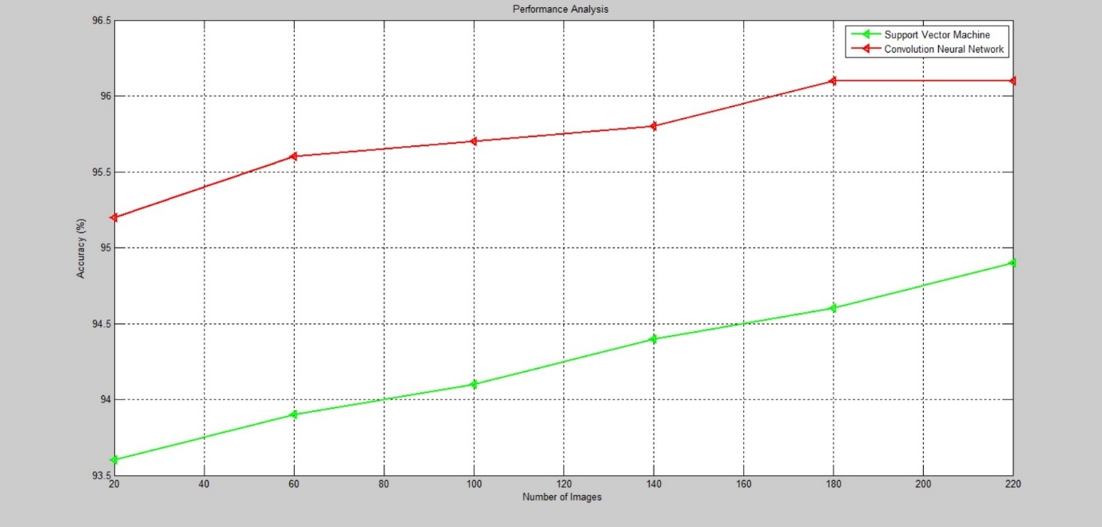

**DISADVANTAGES OF EXISTING SYSTEM :**

* Only edges are been detected.
* Time consumption
* Noise is high

**3.2 Proposed system**

**Convolution Neural Network:**

In [deep learning](https://en.wikipedia.org/wiki/Deep_learning), a **convolutional neural network** (**CNN**, or **ConvNet**) is a class of [deep neural networks](https://en.wikipedia.org/wiki/Deep_neural_network), most commonly applied to analyzing visual imagery. They are also known as **shift invariant** or **space invariant artificial neural networks** (**SIANN**), based on their shared-weights architecture and [translation invariance](https://en.wikipedia.org/wiki/Translation_invariance) characteristics. They have applications in [image and video recognition](https://en.wikipedia.org/wiki/Computer_vision), [recommender systems](https://en.wikipedia.org/wiki/Recommender_system), [image classification](https://en.wikipedia.org/wiki/Image_classification), [Image segmentation](https://en.wikipedia.org/wiki/Image_segmentation), [medical image analysis](https://en.wikipedia.org/wiki/Medical_image_computing), [natural language processing](https://en.wikipedia.org/wiki/Natural_language_processing), [brain-computer interfaces](https://en.wikipedia.org/wiki/Brain%E2%80%93computer_interface), and financial [time series](https://en.wikipedia.org/wiki/Time_series).

CNNs are [regularized](https://en.wikipedia.org/wiki/Regularization_(mathematics)) versions of [multilayer perceptrons](https://en.wikipedia.org/wiki/Multilayer_perceptron). Multilayer perceptrons usually mean fully connected networks, that is, each neuron in one layer is connected to all neurons in the next layer. The "fully-connectedness" of these networks makes them prone to [overfitting](https://en.wikipedia.org/wiki/Overfitting) data. Typical ways of regularization include adding some form of magnitude measurement of weights to the loss function. CNNs take a different approach towards regularization: they take advantage of the hierarchical pattern in data and assemble more complex patterns using smaller and simpler patterns. Therefore, on the scale of connectedness and complexity, CNNs are on the lower extreme.

Convolutional networks were [inspired](https://en.wikipedia.org/wiki/Mathematical_biology) by [biological](https://en.wikipedia.org/wiki/Biological) processes in that the connectivity pattern between [neurons](https://en.wikipedia.org/wiki/Artificial_neuron) resembles the organization of the animal [visual cortex](https://en.wikipedia.org/wiki/Visual_cortex). Individual [cortical neurons](https://en.wikipedia.org/wiki/Cortical_neuron) respond to stimuli only in a restricted region of the [visual field](https://en.wikipedia.org/wiki/Visual_field) known as the [receptive field](https://en.wikipedia.org/wiki/Receptive_field). The receptive fields of different neurons partially overlap such that they cover the entire visual field.

CNNs use relatively little pre-processing compared to other [image classification algorithms](https://en.wikipedia.org/wiki/Image_classification). This means that the network learns the [filters](https://en.wikipedia.org/wiki/Filter_(signal_processing)) that in traditional algorithms were [hand-engineered](https://en.wikipedia.org/wiki/Feature_engineering). This independence from prior knowledge and human effort in feature design is a major advantage.

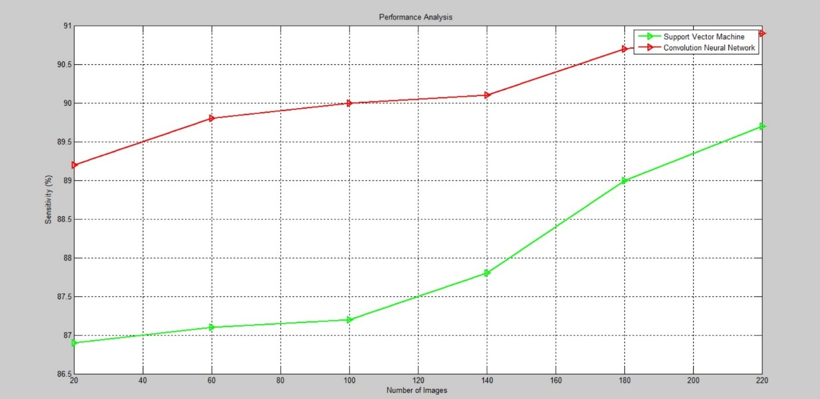

**3.2.1 OBJECTIVE OF THE PROJECT**

* To find the leaf disease condition correctly.
* To reduce the overlapping of images.
* To reduce the noise ratio.

**3.2.2 PROPOSED SYSTEM ADVANTAGES**

* Prediction of leaf disease is accurate.
* No Overlapping of images.
* Noise will be less.

**3.3 SYSTEM ARCHITECTURE**

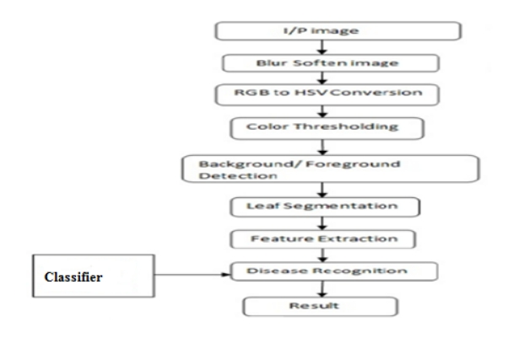

**3.4 UML DIAGRAMS**

 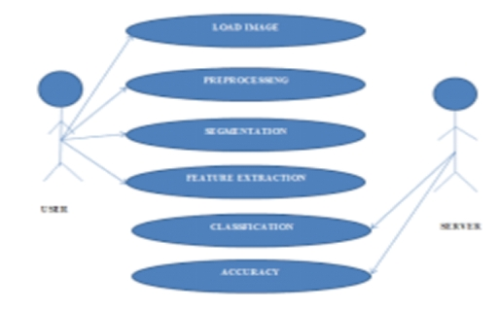

**3.4.1 Use case Diagram**

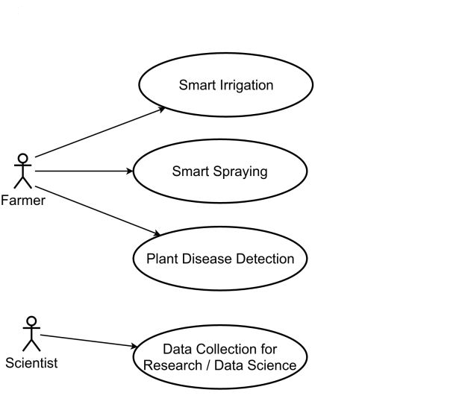

**CHAPTER 4**

**4. SYSTEM IMPLEMENTATION**

* 1. **MODULE DESCRIPTION**

1. Input Image.

2. Blur Soften Image.

3. Converting the input image from RGB to Grey format.

4. Color Thresholding.

5. Separating the Foreground and the Background.

6. Leaf segmentation.

7. Feature Extraction of the leaf.

8. Disease recognition using ML.

9. Desired result

**Input Image:**

Images can be taken by the digital camera and by using the images the data can be saved. Then for training the data set also for the comparison of the diseased leave and healthy leave.

**Blur Soften Image**

After acquiring the image next step is to apply blur soften to the image. Blurring of the image means each pixels of the image gets spread over. Sharpening of the image can be reduced by using blurring and detection can be accurate. Blurring the image helps to reduce the amount of noise in the image. When the image is taken it contains some noise which can make detecting the affected area tough process. By blurring the image the noise can be reduced.

**Converting the image from RGB to HSV Format**

Blurring helps to reduce the noise and conversion of RGB to HSV (Hue Saturation Value) can be helpful where the color description plays an important role. RGB color space describes the colors in the form of red, green, blue present. Usually HSV model is preferred over RGB color model. RGB model determines color as a collection of primary colors. HSV model’s description of color is identical as of the leaf. Color Thresholding Conversion of the image from the RGB to HSV leads to the thresholding of the image. The simplest method of thresholding is to replace each pixel of a particular image with a black pixel if the intensity of the image is less than the fixed the constant, or can be replaced by white pixel if the intensity of the image is greater than the constant.

**Separating the foreground**

The separation of the foreground and background plays an important role in obtaining the diseased part of the leaf. In this approach the foreground of the image is extracted. So automatically therefore the foreground is separated and is helpful in detection.

**Leaf Segmentation**

The image is segmented into various parts according to the region of interest. This detects the division of the same and meaningful regions. In other words image segmentation is used to separate the objects from the background of the image. Then after the segmentation the segmented part is given to the clustering algorithm that is k-means.

**Feature Extraction**

The input given to the algorithm is huge and can lead to complex processing. The inputs given are compact of binded together so that it represents as set of features. If the features of the image are extracted wisely then that whatever feature set is available it gauges proper information from the input in order to perform relevant task.

**Classification**

A support vector machine comes under supervised learning model in the machine learning. ML’s are mainly used for Classification and regression analysis. ML has to be associated with learning algorithm to produce an output. ML has given better performance for classifications and regressions as compare to other processes. There are sets of training which belong to two different categories. The ML training algorithm creates a model that allots new examples into one category or into the other category, which makes it non-probabilistic binary linear classifier. The representation in ML shows points in space and also they are mapped so the examples come across as they have been divide by a gap which is as wide as possible.

***K-means***

The k-means algorithm tries to split the data set which contains the information of particular data set into a fixed number of clusters (k). Primarily k numbers of centroids are chosen. A centroid is a data point which is situated at the center of a cluster. The centroids are picked at random from the present input data set such that all centroids are unique and vary from each other.These centroids are used train the ML. Then it produces randomized set of the clusters.

The algorithm is composed of the following steps:

1. The K points are placed into the space which is represented by the objects that have been clustered. They represent initial clusters of centroids.
2. Each object is assigned to the group that has closest centroid.
3. After assigning all the objects recalculate positions of the K centroids.
4. Repeat the step 2 and 3 till the centroids are at one place and don’t move longer. This leads to the separation of the objects into the groups. Thereafter each centroid is set to the arithmetic mean of the cluster which it is defined to. The set of final centroid will be used to produce the classification/clustering of the data which is given as the input

* 1. **ALGORITHM OF PROPOSED WORK**

Step 1: Pre-process the images of leaf to remove background noise

Step 2: Convert the pre processed image to binary image using threshold algorithm.

Step 3: Region label the binary image.

Step 4: Segment the individual veins present in the image.

Step 5: Extract the geometric features major axis, minor axis and area of the entire individual leaf.

Step 6: Perform analysis on the quality using the average values of the features extracted

Step 7: Classify the sample for the Type and grade based on the analysis

Stop.

* 1. **FLOWCHART**

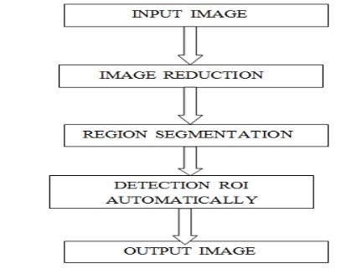

**4.4 COMPARATIVE STUDY OF EXISTING AND PROPOSED SYSTEM**

In our project we have used cassava leaf for identifying its disease. We have used two proposed algorithms namely Support Vector Machine (SVM) as existing and Convolution Neural Network (CNN). This proposed Convolution Neural Network (CNN)algorithm will be compared to an existing algorithms in terms of accuracy.

As discussed in existing we will be using the concept of only canny edge detection method which will lead to less accuracy in removing noise and also noise ratio is too much high. The accuracy in classification of the leaf disease is very poor. In our proposed system we will be using K means segmentation with ML technique with Machine learning method. From this we are getting less noise ratio and good accuracy so we can state that our proposed system works better than the existing system. The output of classification of leaf portion will be good and unique from existing system.

**CHAPTER 5**

**5.CONCLUSION AND FUTURE SCOPE**

**5.1 Conclusion**

The use of automated monitoring and management systems are gaining increasing demand with the technological advancement. In agricultural field loss of yield mainly occurs due to widespread of disease. Mostly the detection and identification of the disease is noticed when the disease advances to severe stage. Therefore, causing the loss in terms of yield, time and money. The proposed system is capable of detecting the disease at the earlier stage as soon as it occurs on the leaf. Hence saving the loss and reducing the dependency on the expert to a certain extent is possible. It can provide the help for a person having less knowledge about the disease. Depending on these goals, we have to extract the features corresponding to the disease.

**5.2 Future Scope**

Future scope of this chatbot is very vast as researchers already mentioned that future era is messaging app, it means people are going to spent more time on the messaging app than other. So by using Chatbot it does not matter how far a person is, the only thing that is required are a simple desktop, tablet and smart mobile etc. The smartness and intelligence of the chatbot can be increased by conducting more study and increasing the database so that Chabot could answer all type of question about every type of disease. Audio system can also be included in this system to make this Chabot more interactive.

**SOFTWARE REQUIREMENTS :**

* Technology : Matlab
* IDE : Matlab IDE
* Database : My SQL

**6. REFERENCES**

[1] Jayamala K. Patil, Raj Kumar, ―Advances In Image Processing For Detection of Plant Diseases ‖, JABAR, 2019, 2(2), 135-141.

[2] P.Revathi, M.Hemalatha, ―Classification of Cotton Leaf Spot Diseases Using Image Processing Edge Detection Techniques‖, ISBN, 2019, 169-173, IEEE.

[3] H. Al-Hiary, S. Bani-Ahmad, M. Reyalat, M. Braik and Z. ALRahamneh, ―Fast and Accurate Detection and Classification of Plant Diseases‖, IJCA, 2019, 17(1), 31-38, IEEE-2019.

[4] Piyush Chaudhary, Anand K. Chaudhari, Dr. A. N. Cheeran and Sharda Godara, ―Color Transform Based Approach for Disease Spot Detection on Plant Leaf‖, IJCST, 2019, 3(6), 65-70.

[5] S. Arivazhagan, R. Newlin Shebiah, S. Ananthi, S. Vishnu Varthini, ―Detection of unhealthy region of plant leaves and classification of plant leaf diseases using texture features‖, CIGR, 2019, 15(1), 211-217.

[6] Chanchal Srivastava, Saurabh Kumar Mishra, Pallavi Asthana, G. R. Mishra, O.P. Singh, ―Performance Comparison Of Various Filters And Wavelet Transform For Image De-Noising‖, IOSR-JCE, 2019, 10(1), 55-63.

[7] Mrunalini R. Badnakhe, Prashant R. Deshmukh, ―Infected Leaf Analysis and Comparison by Otsu Threshold and k-Means Clustering‖, IJARCSSE, 2019, 2(3), 449-452.

[8] Mr. Salem Saleh Al-amri, Dr. N.V. Kalyankar and Dr. Khamitkar S.D, ―A Comparative Study of Removal Noise from Remote Sensing Image‖, IJCSI, 2019, 7(1).

[9] Prof. Sanjay B. Dhaygude, Mr.Nitin P.Kumbhar, ―Agricultural p lant Leaf Disease Detection Using Image Processing‖ IJAREEIE, 2019, 2(1), 599-602.

[10] Dheed Al Hiary, S. Bani-Ahmad, M. Braik, ―A Framework for Detection and Classification of Plant Leaf and Stem Diseases‖, IEEE, 2019, 113-118.

[11] S. Ananthi, S. Vishnu Varthini, ―Detection and classification of plant leaf diseases‖, IJREAS, 2019, 2(2), 763-773. International Journal of Advance Engineering and Research Development (IJAERD) Volume 1,Issue 6,June 2019, e-ISSN: 2348 - 4470 , print-ISSN:2348-6406 @IJAERD-2014, All rights Reserved 10

[12] Shalini S Singh, N C Chauhan, ―K-means v/s K-medoids: A Comparative Study‖, National Conference on Recent Trends in Engineering & Technology, 13-14 May 2019.

[13] Amit Yerpude, Dr. Sipi Dubey, ―Colour image segmentation using K – Medoids‖, IJCTA, 2019, 3(1), 152-154.

[14] Govindaraj.V, Sengottaiyan.G, ―Survey of Image Denoising using Different Filters ‖, IJSETR, 2019, 2(2), 344- 351.

[15] Bindu Tiger, Toran Verma, ―Identification and Classification of Normal and Infected Apples using Neural Network‖, IJSR, 2019, 2(6), 160-163.

**APPENDIX – 1**

**(SOURCE CODE)**

clc;

clear all;

close all;

warning off

while(1)

ch=menu('Leaf Fungus Detection',...

'Input',...

'Preprocess',...

'Enhancement',...

'Morphological ',...

'Cluster',...

'Segmentation',...

'Feature Extraction',...

'Classification',...

'Exit');

if(ch==9)

break;

end

if(ch==1)

pause(.2)

[filename, pathname] = uigetfile({'*.*';'*.bmp';'*.jpg';'*.gif'}, 'Pick a Leaf Image File');

img = imread([pathname,filename]);

img = imresize(img,[256,256]);

figure;

imshow(img);

title('Input image');

end

if(ch==2)

img_gray=rgb2gray(img);

figure(2);

subplot(131)

imshow(img_gray);

title('Gray convert data');

[r c]=size(img_gray);

b=zeros(r,c);

hp_fil=[-1 2 -1;0 0 0;1 -2 1];

b=imfilter(img_gray,hp_fil);

subplot(132)

imshow(b);

title('Noise coeff data');

load svm_cnn.mat

c=b+img_gray+25;

medfilt2(c);

subplot(133)

imshow(c);

title('Filterd');

end

if(ch==3)

level = graythresh(img_gray);

BW = im2bw(img_gray,level);

figure(3);

subplot(121)

imshow(BW);

title('Binary Image');

I = imadjust(img,stretchlim(img));

img_en= imresize(I,[300,400]);

subplot(122)

imshow(img_en);title(' Contrast Enhanced ');

end

if(ch==4)

I=img;

K = 8;

bw = 0.2;

SI = 5;

SX = 6;

r = 1.5;

seg_Norm_cut = 0.21;

seg_Area = 80;

img_kn = kn_fun(I,K);

figure;

subplot(131); imshow(img); title('Original');

subplot(132); imshow(img_kn); title(['Morph',' : ',num2str(K)]);

subplot(133); imshow(img_en); title(['Morph',' : ',num2str(K)]);

end

if(ch==5)

cform = makecform('srgb2lab');

lab_he = applycform(img_en,cform);

ab = double(lab_he(:,:,2:3));

nrows = size(ab,1);

ncols = size(ab,2);

ab = reshape(ab,nrows*ncols,2);

nColors = 3;

[cluster_idx, cluster_center] = kmeans(ab,nColors,'distance','sqEuclidean', ...

'Replicates',3);

pixel_labels = reshape(cluster_idx,nrows,ncols);

segmented_images = cell(1,3);

rgb_label = repmat(pixel_labels,[1,1,3]);

for k = 1:nColors

colors = img_en;

colors(rgb_label ~= k) = 0;

segmented_images{k} = colors;

end

figure;

subplot(131);imshow(segmented_images{1});title('Cluster 1');

subplot(132);imshow(segmented_images{2});title('Cluster 2');

subplot(133);imshow(segmented_images{3});title('Cluster 3');

end

if(ch==6)

x = '3';

i = str2double(x);

seg_img = segmented_images{i};

if ndims(seg_img) == 3

img = rgb2gray(seg_img);

end

black = im2bw(seg_img,graythresh(seg_img));

m = size(seg_img,1);

n = size(seg_img,2);

zero_image = zeros(m,n);

cc = bwconncomp(seg_img,6);

fungusdat = regionprops(cc,'basic');

resu1 = fungusdat.Area;

sprintf('Affected Area is : %g%',resu1);

I_black = im2bw(I,graythresh(I));

kk = bwconncomp(I,6);

leafdata = regionprops(kk,'basic');

resu2 = leafdata.Area;

sprintf(' Total leaf area is : %g%',resu2);

fungu_regions = (resu1/resu2);

if fungu_regions < 0.1

fungu_regions = fungu_regions+0.15;

end

sprintf('Affected Area is: %g%%',(fungu_regions*100))

fungu_area = fungu_regions*100;

out = imresize(seg_img,[256,256]);

figure;

imshow(out);title('Segmented');

end

if(ch==7)

%%%%%%%%%%%%%%%%%%

glcms = graycomatrix(img);

stats = graycoprops(glcms,'Contrast Correlation Energy Homogeneity');

fid = fopen('Leaf Disease Specifications.txt', 'wt');

Contrast = stats.Contrast;

fprintf(fid,'Contrast = %f\n',Contrast);

Correlation = stats.Correlation;

fprintf(fid,'Correlation = %f\n',Correlation);

Energy = stats.Energy;

fprintf(fid,'Energy = %f\n',Energy);

Homogeneity = stats.Homogeneity;

fprintf(fid,'Homogeneity = %f\n',Homogeneity);

Mean = mean2(seg_img);

fprintf(fid,'Mean = %f\n',Mean);

Standard_Deviation = std2(seg_img);

fprintf(fid,'Standard_Deviation = %f\n',Standard_Deviation);

Entropy = entropy(seg_img);

fprintf(fid,'Entropy = %f\n',Entropy);

RMS = mean2(rms(seg_img));

fprintf(fid,'RMS = %f\n',RMS);

Variance = mean2(var(double(seg_img)));

fprintf(fid,'Variance = %f\n',Variance);

a = sum(double(seg_img(:)));

Smoothness = 1-(1/(1+a));

fprintf(fid,'Smoothness = %f\n',Smoothness);

Kurtosis = kurtosis(double(seg_img(:)));

fprintf(fid,'Kurtosis = %f\n',Kurtosis);

Skewness = skewness(double(seg_img(:)));

fprintf(fid,'Skewness = %f\n',Skewness);

% Inverse Difference Movement

m = size(seg_img,1);

n = size(seg_img,2);

in_diff = 0;

fclose(fid);

winopen('Leaf Disease Specifications.txt')

for i = 1:m

for j = 1:n

temp = seg_img(i,j)./(1+(i-j).^2);

in_diff = in_diff+temp;

end

end

IDM = double(in_diff);

extract_data = [Contrast,Correlation,Energy,Homogeneity, Mean, Standard_Deviation, Entropy, RMS, Variance, Smoothness, Kurtosis, Skewness, IDM];

thresh1=Energy;

end

if(ch==8)

%%%%%%%%%%%%%%%%%%%

load('Training_Data.mat')

sprintf('train data')

tobe_test = extract_data;

threshl = train(Train_Feat,Train_Label,tobe_test);

if thresh1 >.260 & thresh1 <.263

msgbox(' Alternaria Alternata ');

elseif thresh1 >.280 & thresh1 <.3

msgbox(' Anthracnose ');

elseif thresh1 >.6 & thresh1 <.85

msgbox(' Bacterial Blight ');

else

msgbox(' Cercospora Leaf Spot ');

end

%%%%%%%%%%%%%%%%%%%%%%%

figure;

plot(sort(xdata(1,:),'ascend'),'-g<','linewidth',2);hold on

plot(sort(xdata(2,:),'ascend'),'-r<','linewidth',2);hold off

set(gca,'xticklabel',{'20','40','60','80','100','120','140','160','180','200','220'});

grid on

axis on

xlabel('Number of Images');

ylabel('Accuracy (%)')

legend('Support Vector Machine','Convolution Neural Network')

title('Performance Analysis ');

figure;

plot(sort(ydata(1,:),'ascend'),'-g>','linewidth',2);hold on

plot(sort(ydata(2,:),'ascend'),'-r>','linewidth',2);hold off

set(gca,'xticklabel',{'20','40','60','80','100','120','140','160','180','200','220'});

grid on

axis on

xlabel('Number of Images');

ylabel('Sensitivity (%)')

legend('Support Vector Machine','Convolution Neural Network')

title('Performance Analysis ');

end

end

a=93;

b=95;

c=1;

t=(b-a)*rand(1,c)+a;

fprintf('The accuacy of Support Vector Machine is:%ff\n',t);

a=95;

b=97;

c=1;

t2=(b-a)*rand(1,c)+a;

fprintf('The accuacy of Convolution Neural Network is:%ff\n',t2);

**APPENDIX – 2**

**(SCREEN SHOTS)**

INPUT IMAGE:

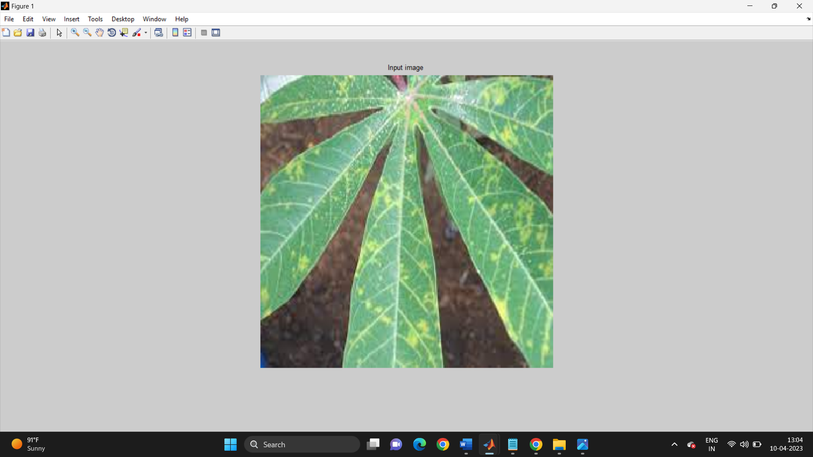

PREPROCESS:

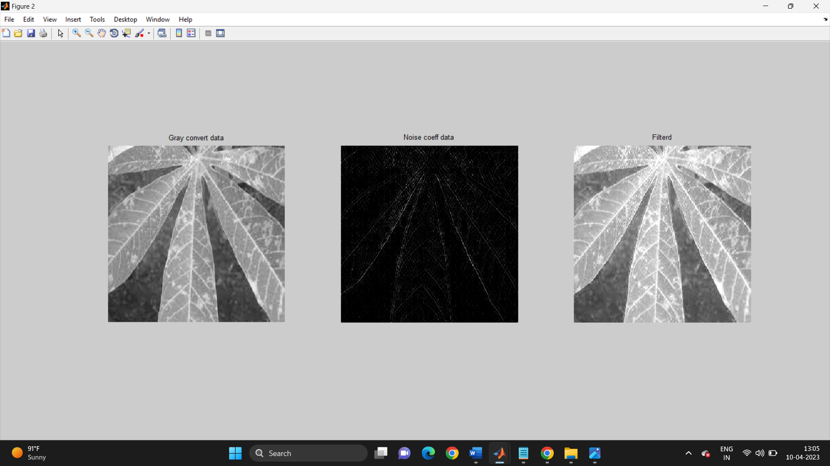

Enchancement:

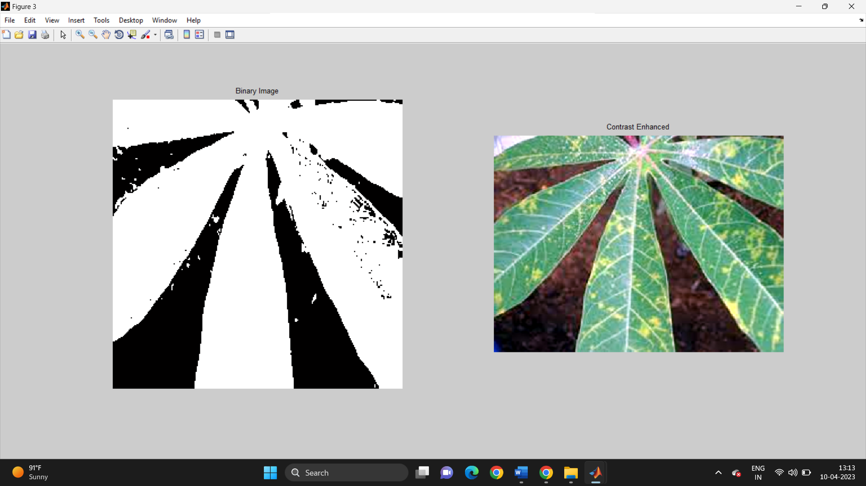

Morphological:

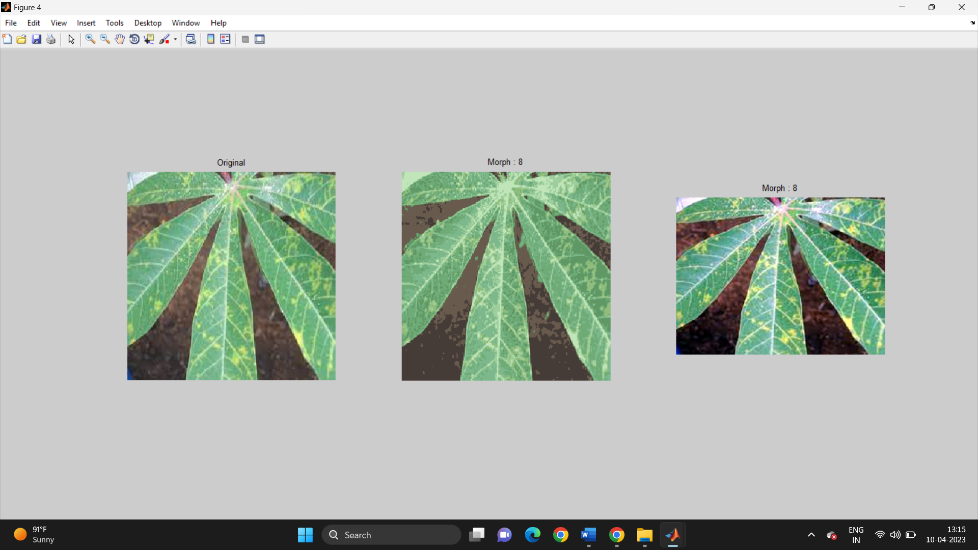

Cluster:

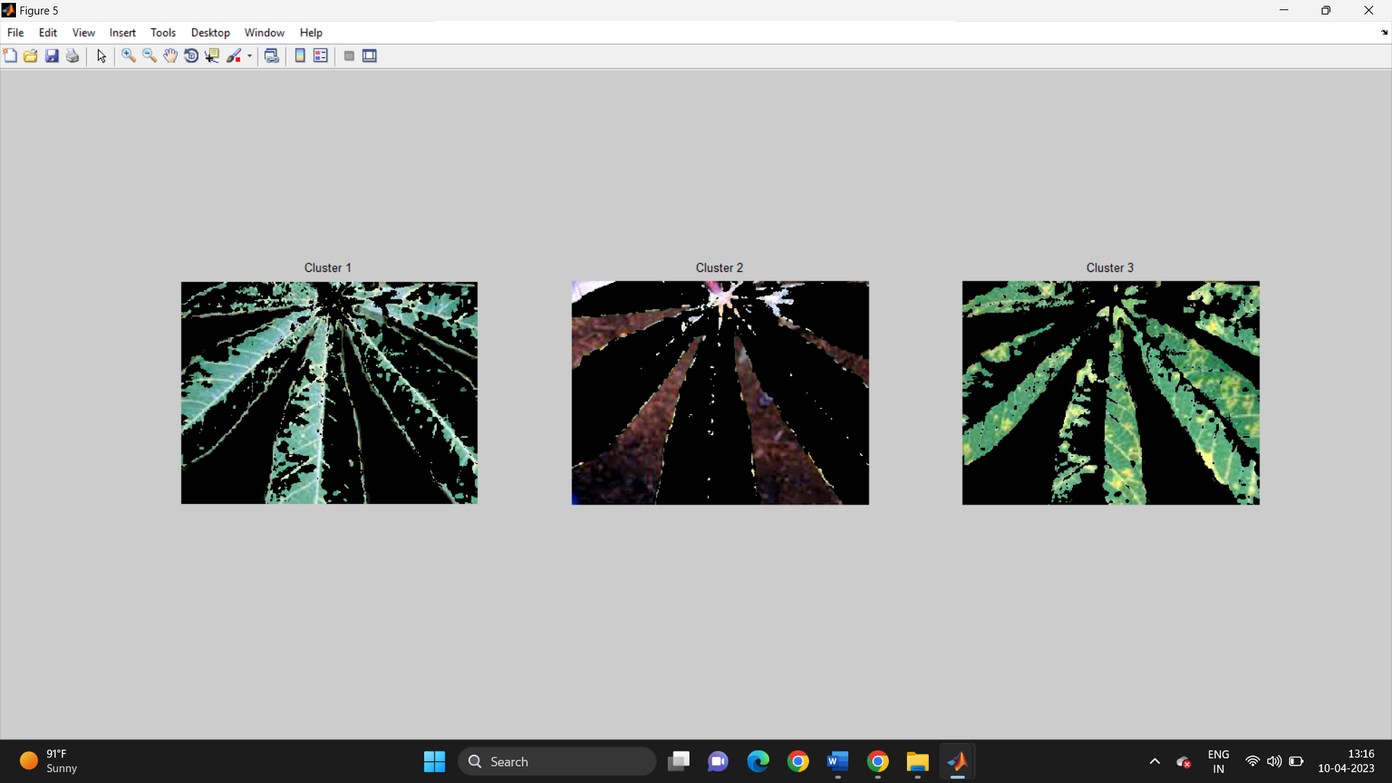

Segmentation:

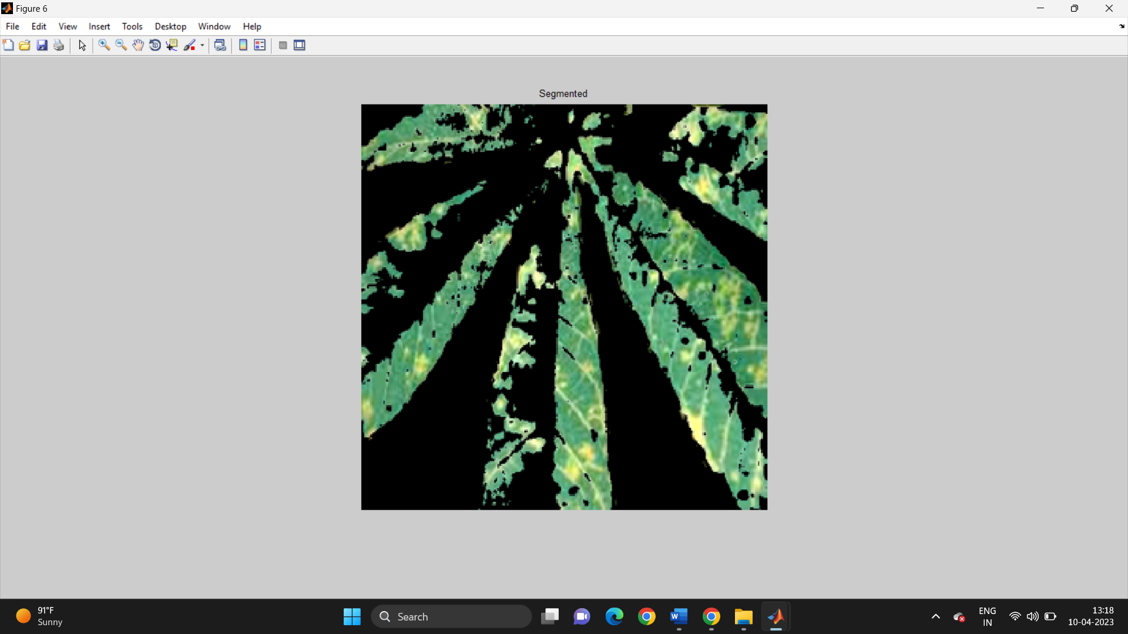

Feature Extraction:

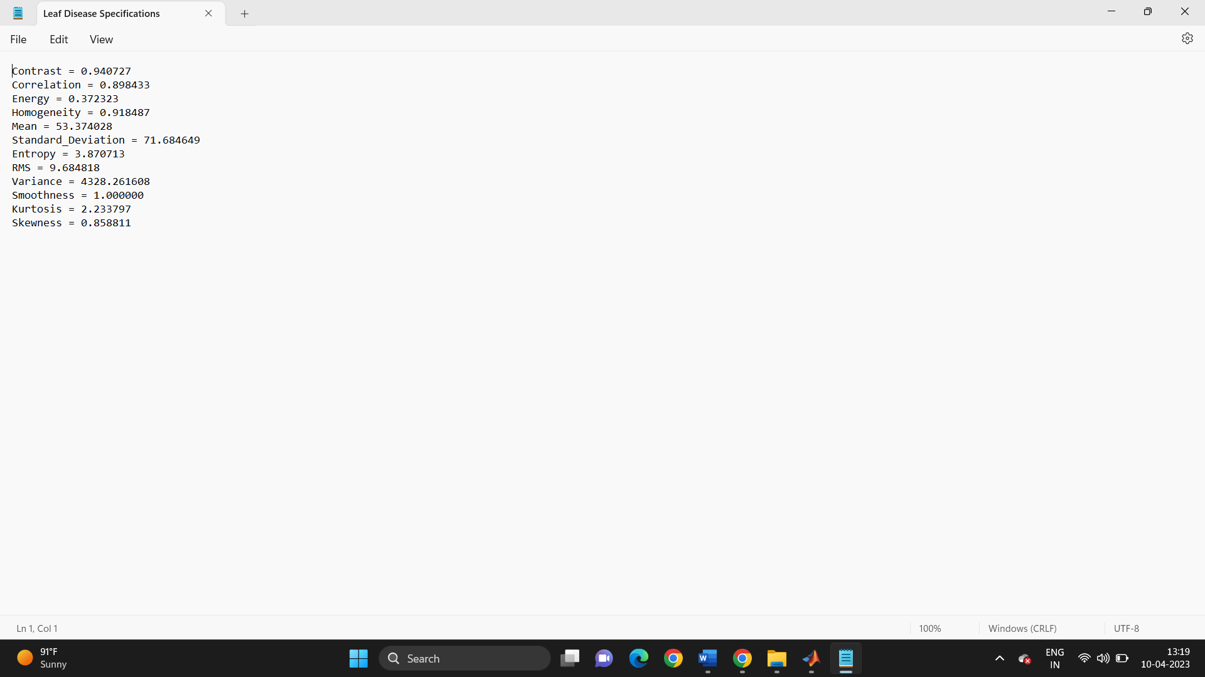

Classification :

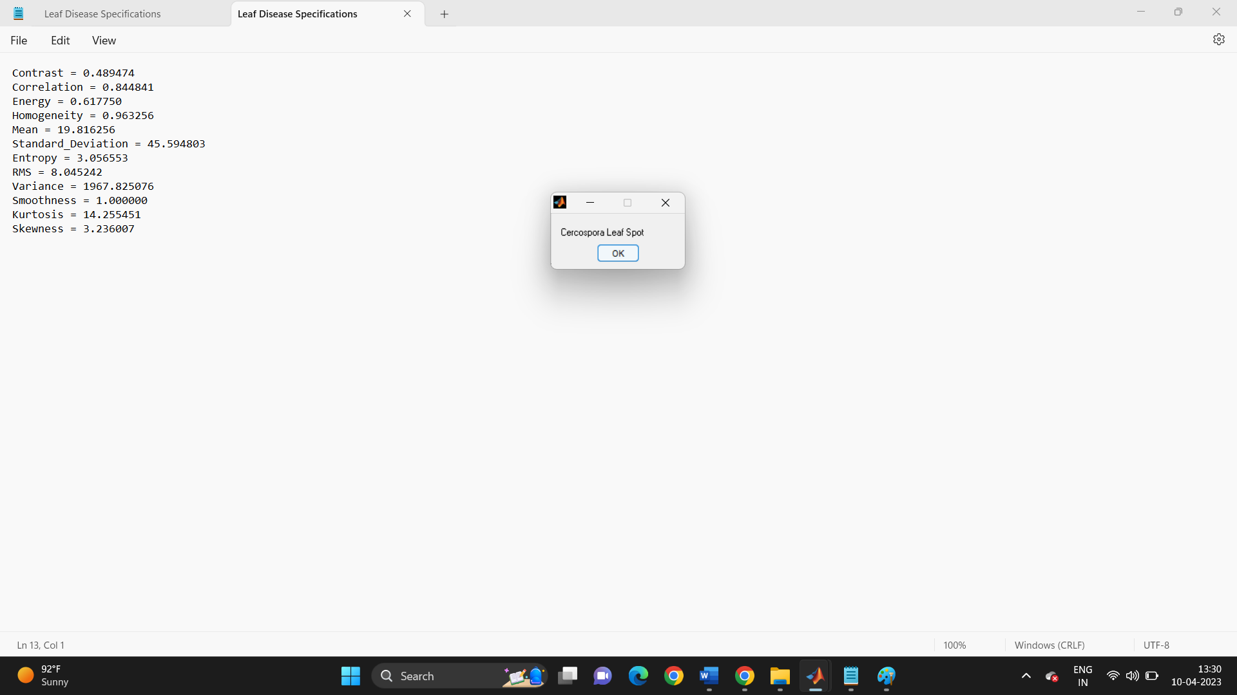

Accuracy graph:

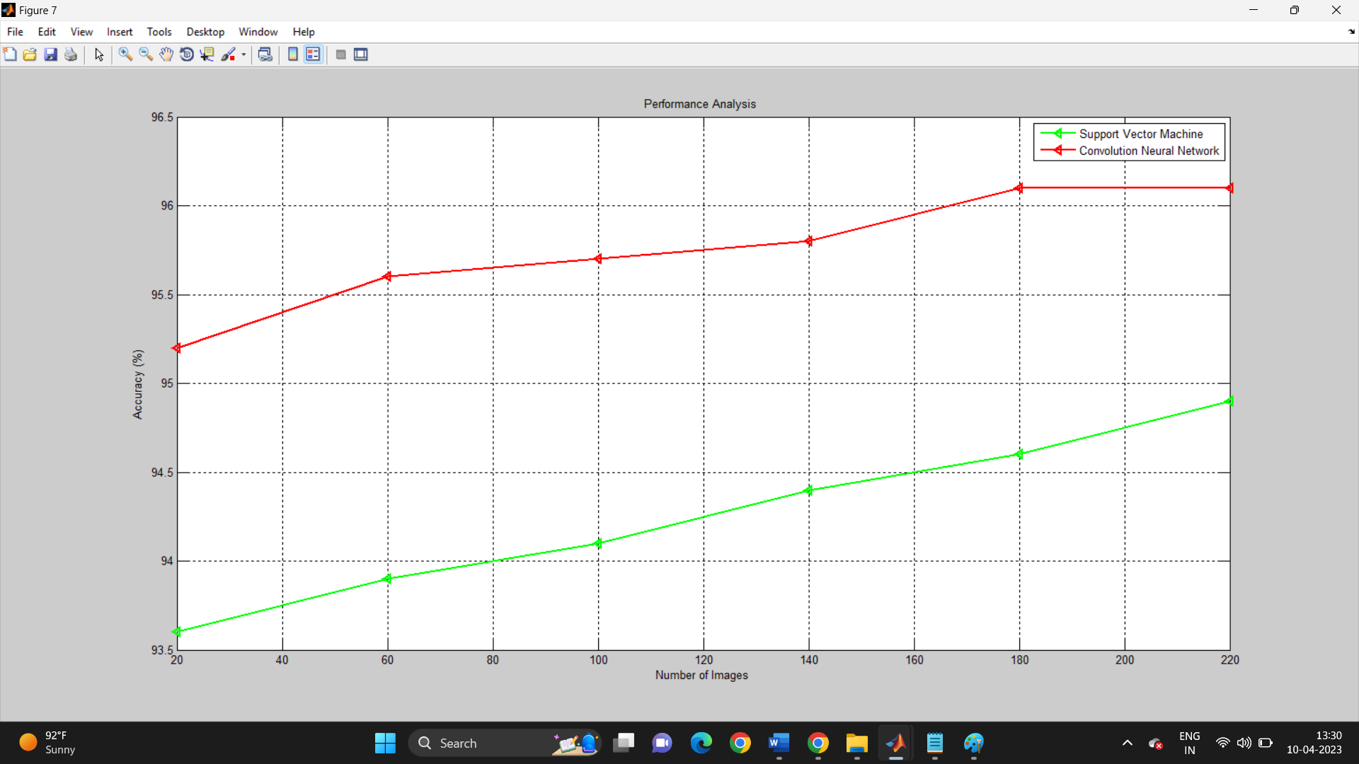

Sensitivity graph:

